I conducted a stationarity analysis on the four time series: UNRATE, GDP, CPALTT01USM657N, and FEDFUNDS. For the UNRATEseries, the ADF test statistic was -2.22, which was greater than the critical value of -2.85, indicating that I failed to reject the null hypothesis of non-stationarity. The series showed a slow decay in its ACF and significant values in the PACF, further confirming non-stationarity. I would need to apply differencing or transformations to make this series stationary.

For the GDP series, I observed a strong upward trend, and the ADF test statistic of -0.28, much greater than the critical value of -2.85, confirmed non-stationarity. The ACF displayed a slow decay, and the PACF did not exhibit a clear cutoff, reinforcing the need for differencing or log transformations to achieve stationarity.

When analyzing the CPALTT01USM657N series, I noticed that it appeared relatively stable, and the ADF test statistic of -3.03 was less than the critical value of -2.85. This allowed me to reject the null hypothesis, concluding that the series is stationary on its original value. Both the ACF and PACF confirmed this result, as they decayed quickly and lacked significant long-term autocorrelations. No additional transformations were needed for this series.

Finally, for the FEDFUNDS series, I found the ADF test statistic to be -2.94, which was also less than the critical value of -2.85. This indicated that the series was stationary but it needs to be differentiated to make stationary . The ACF decayed gradually, and the PACF displayed a significant spike at lag 1, but there was no strong evidence of long-term dependencies. I determined that the FEDFUNDS series is not ready for direct analysis without further modifications.

1st differentiation of the data set:

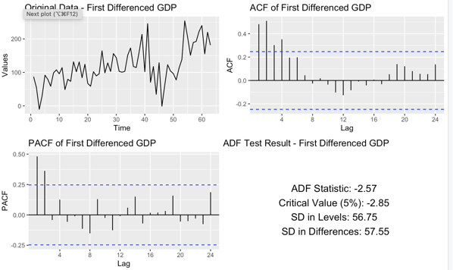

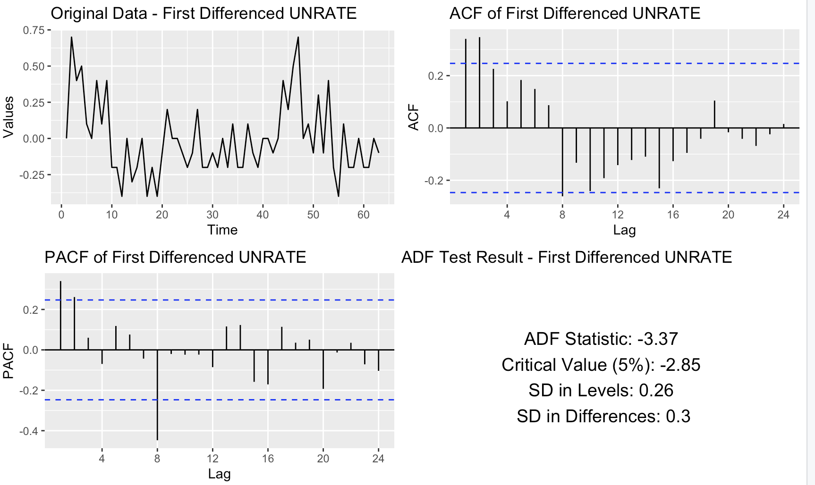

I analyzed the stationarity of the first-differenced series for GDP, UNRATE, and FEDFUNDS. For the first-differenced GDP series, I observed that the trend was removed, and the series fluctuated around a constant mean. However, the ADF test statistic of -2.57 was greater than the critical value of -2.85, meaning I could not reject the null hypothesis of non-stationarity. This indicated that while first differencing removed the trend, the series still exhibited some non-stationary behavior, and further differencing or modeling might be necessary.

When I analyzed the first-differenced UNRATE series, the ADF test statistic of -3.37 was smaller than the critical value of -2.85. This allowed me to reject the null hypothesis of non-stationarity and conclude that the series became stationary after first differencing. The ACF and PACF plots confirmed this, as the autocorrelations decayed quickly, with only a few significant spikes at lower lags. The differencing effectively removed the trend and made the series ready for further analysis.

For the first-differenced FEDFUNDS series, I observed that the trend had been successfully removed, and the series stabilized with consistent fluctuations. The ADF test statistic of -3.17 was also smaller than the critical value of -2.85, allowing me to reject the null hypothesis and conclude that the series was stationary after first differencing. The ACF and PACF plots confirmed this result, showing a quick decay in autocorrelations and no long-term dependencies.

2nd differentiating of GDP

I analyzed the stationarity of the second-differenced GDP series to address the non-stationarity observed after the first differencing. The second differencing effectively removed both the linear and quadratic trends, as evident from the original data plot, where the fluctuations are now centered around a constant mean with consistent variability.

The ADF test statistic was -5.31, which is significantly smaller than the critical value of -2.85 at the 5% significance level. This allowed me to reject the null hypothesis of non-stationarity, confirming that the series became stationary after applying the second differencing. The ACF plot showed a rapid decay with no strong autocorrelations at higher lags, and the PACF plot displayed only a few significant spikes at lower lags, which further validated the stationarity of the series.

The standard deviation in levels was 57.55, while the standard deviation after second differencing increased to 102.24. Although there was a rise in variability after differencing, I believe this is typical when dealing with time series data and does not affect the conclusion of stationarity.

The phrase “VARs are like the *Who’s Line Is It Anyway* of econometrics. The equations are real but the parameters don’t matter” reflects a common interpretation of how Vector Autoregression (VAR) models are used in econometrics. To break this down, while the equations in a VAR model represent legitimate relationships among variables, the individual parameters (coefficients) themselves are often not the focus. Instead, the real utility of VAR models lies in understanding the overall system dynamics, not in interpreting individual parameter estimates.

In a VAR model, every variable is treated symmetrically, and each is explained by its own lagged values and the lagged values of all other variables in the system.

For example, in a VAR(1) model with two variables Ytand Xt, the equations look like this:

Here, the parameters ϕij show how lagged values of Yt and Xt influence the current values of each variable. While these equations are real in the sense that they are derived from data and rigorously estimated, the specific values of the coefficients ϕij don’t usually matter as much for interpretation. This is because VAR models are typically used not for directly analyzing these parameters but for tasks like forecasting, impulse response analysis, and variance decomposition.

For instance, impulse response functions (IRFs) are a key tool in VAR analysis. They describe how a shock to one variable (like an unexpected increase in interest rates) impacts all variables in the system over time. The IRFs are computed using the estimated coefficients, but the focus is on the **dynamic response** rather than the coefficients themselves. In other words, the IRFs help us understand the system’s behavior, not the numerical values of the ϕij.

Another application is variance decomposition, which quantifies how much of the forecast error variance for each variable is explained by shocks to itself versus shocks to other variables. Again, this shifts attention from the specific coefficients to the system-wide interactions.

Mathematically, VAR models can be represented compactly as

where Yt​ is a vector of variables (e.g., [Yt,Xt], Φs the matrix of coefficients, and ϵt represents the error terms. The dynamics of the system depend on the structure of Φ, but interpreting individual elements of Φ is less important than analyzing the impulse responses or the stability of the system.

In practice, the specific values of the coefficients may only matter for constructing forecasts or deriving IRFs, but they are not typically the focus of analysis. Instead, we are interested in broader questions like: "How does a shock to interest rates affect GDP and inflation over time?" or "What percentage of the variability in inflation is explained by shocks to oil prices?" so we can say that he statement highlights that while the equations in a VAR model are valid and grounded in econometric theory, the individual parameters are secondary to the bigger picture. The real insights come from analyzing how the system behaves, such as through IRFs or variance decomposition. This makes VAR models powerful tools for understanding dynamic relationships, even if the parameters themselves don’t seem to “matter.



The VAR model analysis allowed me to explore the dynamic relationships among GDP, the Federal Funds Rate (FEDFUNDS), the Unemployment Rate (UNRATE), and the Consumer Price Index (CPALTT01USM657N). For GDP as the dependent variable, I noticed that its first lag (GDP.L1) had a strong and significant negative impact, reinforcing the importance of autoregressive effects. Additionally, the unemployment rate (UNRATE.L1) showed a significant positive influence, suggesting that changes in employment levels can have immediate implications for economic output. However, most higher-order lags of all variables had minimal or no significant effects, indicating that GDP is primarily influenced by its recent past values and immediate changes in unemployment.

When focusing on FEDFUNDS as the dependent variable, I found limited significance among most variables. A notable finding was that the fourth lag of GDP (GDP.L4) had a weakly positive effect, while the fifth lag of unemployment (UNRATE.L5) showed a significant negative impact, highlighting a delayed influence of labor market dynamics on monetary policy. This aligns with expectations that interest rate adjustments often respond to shifts in employment, albeit with some lag. Interestingly, the FEDFUNDS series itself exhibited weak autoregressive patterns, suggesting that other external factors likely dominate its fluctuations.

For UNRATE as the dependent variable, the analysis revealed significant negative effects from the first and fourth lags of GDP (GDP.L1 and GDP.L4), affirming the inverse relationship between economic growth and unemployment. Additionally, the unemployment rate showed strong persistence, as evidenced by the positive effects of its own lags (UNRATE.L2 and UNRATE.L5). This suggests that unemployment levels are heavily influenced by their own recent history, reflecting the inertia often observed in labor market dynamics. The Federal Funds Rate (FEDFUNDS.L4) also contributed positively and significantly, indicating that monetary tightening could lead to higher unemployment after a delay.

Finally, when CPALTT01USM657N was the dependent variable, I observed that the fourth lag of unemployment (UNRATE.L4) had a positive and significant impact, suggesting that changes in labor market conditions eventually affect price levels. I also found a negative and significant effect from the third lag of CPALTT01USM657N itself (CPALTT01USM657N.L3), indicating a corrective or stabilizing mechanism in the price index over time. Interestingly, GDP and the Federal Funds Rate had no significant influence on CPALTT01USM657N, reinforcing the idea that CPI movements are driven more by unemployment trends and their own lagged behavior.

In summary, this analysis highlighted the unique roles and interdependencies of these economic indicators. GDP dynamics are dominated by its own past values and immediate unemployment changes, while the Federal Funds Rate responds weakly to GDP and unemployment. Unemployment itself is highly persistent and influenced by past economic growth and monetary policy decisions. Finally, the Consumer Price Index is significantly shaped by unemployment trends and its own lagged patterns. These findings align with economic theory and offer insights into the short- and long-term interactions between key macroeconomic variables.

for my analysis, I relied on the Akaike Information Criterion (AIC) to determine the optimal lag length for the VAR model. The AIC is a statistical metric that balances model complexity and fit, guiding me toward selecting the most efficient model without overfitting the data. By minimizing the AIC value, I could identify the lag structure that best captured the relationships among the variables while avoiding unnecessary complexity. For my model, the AIC value was 613.2369, which confirmed the chosen lag order ****as optimal under the specified maximum lag constraint.

In a structural VAR model, contemporaneous interactions refer to the instantaneous relationships between variables within the same time period. These are typically represented in the structural innovations matrix (AA) of the SVAR model

A captures contemporaneous relationships among variables are structural shocks.Without restrictions, AA cannot be uniquely identified from the reduced-form VAR.

Placing restrictions on contemporaneous interactions in a VAR model is crucial for ensuring the model’s identifiability and interpretability, especially in Structural VARs (SVARs). Contemporaneous interactions represent the instantaneous relationships among variables within the same time period, and without restrictions, the structural shocks cannot be uniquely identified. These restrictions reduce the parameter space and make the model estimable, while also reflecting economic theory and simplifying the interpretation of results.

One common approach is recursive restrictions, often implemented using Cholesky decomposition. This method imposes a causal ordering among variables, where a variable higher in the hierarchy can influence others contemporaneously, but not vice versa. For instance, GDP might be allowed to affect inflation contemporaneously, but inflation is assumed not to impact GDP within the same period. Another approach involves theory-based restrictions, derived from economic models. For example, monetary policy models often assume that central banks respond contemporaneously to inflation and output gaps, but not immediately to shocks in financial markets. Similarly, aggregate demand and supply models might assume that demand shocks have a contemporaneous effect on prices but only a delayed impact on output.

Some models also incorporate long-run restrictions, such as assuming that monetary shocks have no long-term effect on output levels, as demonstrated by Blanchard and Quah (1989) in separating demand and supply shocks. Zero restrictions are another useful tool, where specific variables are assumed not to respond to certain shocks contemporaneously. For example, stock market shocks might not influence GDP instantaneously, reflecting the lagged transmission of financial market dynamics to the broader economy.

The choice of restrictions should be guided by both theoretical reasoning and empirical evidence. Literature such as Blanchard and Quah (1989), Sims (1980), and Bernanke (1986) provides a foundation for implementing meaningful restrictions, tailored to specific research questions. By placing appropriate constraints, researchers can recover structural shocks and analyze their dynamic effects, ensuring the results are both interpretable and aligned with economic theory.



An Impulse Response Function (IRF) helps us understand how a system of variables reacts to a sudden, unexpected change in one of its components, while keeping all other factors constant. It essentially measures the dynamic response of one variable to a shock or disturbance in another variable over time.

Mathematical Definition,

In a VAR model, an IRF shows how a one-unit shock in one variable (say, an increase in interest rates) affects all variables in the system (such as GDP, inflation, or unemployment) over time. Mathematically, it’s expressed as:

This means it calculates how variable Yjchanges hh periods after a shock occurs in Yk​. The coefficients in the IRF come from solving the VAR equations iteratively to express each variable as a function of past shocks.

An Impulse Response Function (IRF) intuitively captures how a system of variables reacts over time to a sudden shock in one of its components. Let’s Imagine tossing a pebble into a still pond and watching the ripples spread outward. The initial splash is like the immediate effect of the shock, and the ripples represent how the impact spreads to other variables and fades (or amplifies) over time. For example, if there’s an unexpected increase in interest rates, the IRF can show how GDP, inflation, and other variables respond in the short term and how these effects evolve over subsequent periods. Perhaps GDP drops immediately as borrowing costs rise, inflation slows down over the next few months, and eventually, both variables stabilize back to their normal levels. The IRF provides a dynamic picture of this process, showing not only the size of the response but also how long it lasts and whether it reverses direction. In essence, it helps us trace the chain reaction of cause and effect in a system, providing valuable insights into the interconnectedness and behavior of variables over time.

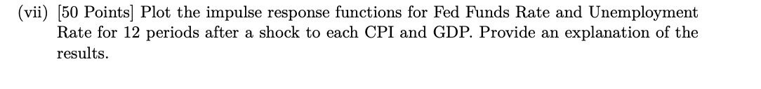

When interpreting the results from the impulse response functions, I focused on understanding how the Fed Funds Rate (FEDFUNDS) and Unemployment Rate (UNRATE) responded dynamically to a shock in the system over a 12-period horizon. The responses of these two variables provided me with valuable insights into the time-varying adjustments within the economy.

In response to a shock to the Consumer Price Index (CPI), I observed that the Fed Funds Rate initially increased, peaking around the 3rd or 4th period. This rise reflected the typical monetary policy reaction to inflationary pressures, as central banks often increase interest rates to counteract inflation. Over time, the Fed Funds Rate tapered off, returning to its baseline around the 7th or 8th period. On the other hand, the Unemployment Rate exhibited a slight negative response in the initial periods, suggesting a temporary decrease in unemployment likely due to short-term economic activity spurred by inflation. However, this effect diminished quickly, with unemployment returning to its pre-shock level by the 5th or 6th period. The confidence intervals showed higher precision for the Fed Funds Rate response compared to the broader intervals for unemployment, which indicated greater uncertainty in the latter's estimates.

In response to a GDP shock, I observed a sharp initial drop in the Fed Funds Rate, hitting its lowest point around the 2nd or 3rd period. This decrease reflected an accommodative monetary policy approach, where interest rates were lowered to stimulate economic recovery following a decline in GDP. Over the subsequent periods, the Fed Funds Rate gradually recovered, approaching zero and even turning slightly positive by the 8th to 12th period. For the Unemployment Rate, the initial response was a significant increase, peaking around the 2nd period as the GDP shock disrupted economic output and led to higher unemployment. Over time, unemployment gradually decreased, stabilizing near its pre-shock level by the 8th to 10th period. The confidence intervals indicated relatively higher precision for the Fed Funds Rate's response, while the Unemployment Rate's wider intervals reflected greater variability in its reaction to GDP shocks. Together, these responses highlight how monetary policy and labor market adjustments occur in the wake of macroeconomic shock.